Timers in Compare Mode - Part II

Hello and welcome back to the discussion on the TIMERs in compare mode. In the last article we discussed the basics and the theory about using the timer in compare mode. Now its time to write some practical code and run it in real world. The project we are making is a simple time base which is very useful for other project requiring accurate computation of time like a digital clock or a timer that automatically switches devices at time set by user. You can use it for any project after understanding the basics.
We will have three global variable which will hold the millisecond, second and minutes of time elapsed. These variables are automatically updated by the compare match ISR. Look at the figure below to get an idea how this is implemented.
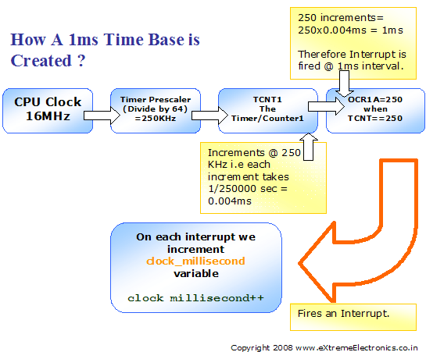

Fig - Using AVR Timer to generate 1ms Time base.

Complete Code

#include <avr/io.h>
#include <avr/interrupt.h>

#include "lcd.h"

//Global variable for the clock system
volatile unsigned int clock_millisecond=0;
volatile unsigned char clock_second=0;

volatile unsigned char clock_minute=0;

main()
{
//Initialize the LCD Subsystem
InitLCD(LS_BLINK);
//Clear the display
LCDClear();

//Set up the timer1 as described in the
//tutorial

TCCR1B=(1<<WGM12)|(1<<CS11)|(1<<CS10);
OCR1A=250;

//Enable the Output Compare A interrupt
TIMSK|=(1<<OCIE1A);

LCDWriteStringXY(0,0,"Time Base Demo");
LCDWriteStringXY(0,1," : (MM:SS)");

//Enable interrupts globally

sei();

//Continuasly display the time
while(1)
{
LCDWriteIntXY(0,1,clock_minute,2);
LCDWriteIntXY(3,1,clock_second,2);
_delay_loop_2(0);
}

}

//The output compate interrupt handler
//We set up the timer in such a way that
//this ISR is called exactly at 1ms interval
ISR(TIMER1_COMPA_vect)
{
clock_millisecond++;
if(clock_millisecond==1000)
{
clock_second++;
clock_millisecond=0;
if(clock_second==60)
{
clock_minute++;
clock_second=0;
}
}
}

Hardware
The hardware is ATmega8-16PU running at 16MHz with a LCD Connected to it. I have used AVR BOARD to make the prototype. You can also use your own ATmega8 board. The output is displayed in a 16x2 character LCD module so please see the LCD interfacing tutorial for information about the connections and use. I recommend you to first setup and test the LCD interfacing because it will help you in many projects. If you have any problems setting it up.

Fig – AVR Board can be used to prototype many projects easily!

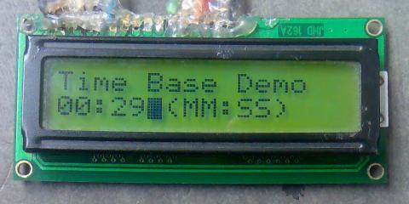

Fig - The output of above program in 16x2 LCD module.

